## EC2 Instance and S3 Buckets Aim:

To create an EC2 instance and an S3 bucket in AWS.

## Procedure

### Step 1: Creating an EC2 Instance

1. **Sign in to the AWS Management Console:**
   * Go to <https://console.aws.amazon.com/>
   * Log in using your AWS account credentials. Remember to log in with your administrative user, not the root user.
2. **Navigate to the EC2 Service:**
   * In the AWS Management Console, find "EC2" using the search bar or by navigating through the services menu.
3. **Launch an Instance:**
   * Click "Launch Instance".
4. **Choose an Amazon Machine Image (AMI):**
   * Select an AMI (operating system) for your EC2 instance. Choose one that meets your needs (e.g., Amazon Linux 2, Ubuntu, Windows Server). Consider the Free Tier options.
5. **Choose an Instance Type:**
   * Select an instance type. This determines the hardware configuration of your instance (e.g., CPU, memory). Choose a "t2.micro" instance for the Free Tier, if available.
6. **Configure Instance Details:**
   * Configure the instance settings, such as the number of instances, network settings (VPC, subnet), and IAM role. For basic setup, you can often accept the defaults.
7. **Add Storage:**
   * Specify the size and type of storage volumes to attach to your instance. The default is usually sufficient for initial setup. Consider the Free Tier limits.
8. **Add Tags (Optional):**
   * Add tags to your instance. Tags are key-value pairs that help you organize and manage your AWS resources. For example, you can tag an instance with "Name" = "MyWebAppInstance".
9. **Configure Security Group:**
   * A security group acts as a virtual firewall for your instance. Configure rules to control inbound and outbound traffic.
     + For example, allow SSH access (port 22) from your IP address.
     + If you plan to run a web server, allow HTTP access (port 80) and/or HTTPS access (port 443) from 0.0.0.0/0 (all IP addresses). **Security Warning:** For production environments, restrict access to only necessary IP addresses.
10. **Review and Launch:**
    * Review your instance configuration.
    * Click "Launch".
11. **Create a Key Pair:**
    * A key pair consists of a public key that AWS stores, and a private key file that you keep. You use the private key to securely connect to your EC2 instance.
      + Create a new key pair or select an existing one.
      + **Important:** Download the private key file (.pem file) and store it in a secure location. You will not be able to download it again.
      + Acknowledge that you have the private key and click "Launch Instances".
12. **Connect to Your Instance:**
    * Once the instance has launched, you can connect to it using the private key file and a terminal application (e.g., PuTTY on Windows, or the built-in terminal on macOS and Linux).
    * The exact steps vary depending on your operating system. AWS provides instructions in the EC2 console.

### Step 2: Creating an S3 Bucket

1. **Navigate to the S3 Service:**
   * In the AWS Management Console, find "S3" using the search bar or by navigating through the services menu.
2. **Create a Bucket:**
   * Click "Create bucket".
3. **Enter Bucket Name:**
   * Enter a unique name for your bucket. Bucket names must be globally unique across all AWS accounts.
4. **Choose a Region:**
   * Select the AWS Region where you want to create the bucket. Choose a region that is geographically close to you or your users.
5. **Configure Bucket Settings:**
   * Configure bucket settings, such as:
     + **Object Ownership:** Choose who owns the objects in the bucket.
     + **Block Public Access:** By default, S3 buckets are private. It is highly recommended to keep "Block all public access" enabled unless you have a specific reason to make your bucket public. If you need to serve static website content, there are specific steps to follow, but proceed with caution.
     + **Bucket Versioning:** Enable versioning to keep multiple versions of an object in the same bucket. This can be useful for data recovery.
     + **Tags:** Add tags to your bucket for organization and cost tracking.
     + **Encryption:** Enable server-side encryption to protect data at rest. AWS recommends using server-side encryption.
6. **Create Bucket:**
   * Review your bucket configuration and click "Create bucket".
7. **Upload Objects:**
   * Once the bucket is created, you can upload objects (files) to it using the AWS Management Console, the AWS CLI, or the AWS SDKs.

### Step 3: Securing your AWS resources.

1. **Secure your AWS account root user:**
   * Sign in to the AWS Management Console (<https://console.aws.amazon.com>) as the account owner by choosing Root user and entering your AWS account email address. On the next page, enter your password.
   * Turn on multi-factor authentication (MFA) for your root user.
2. **Create user with administrative access:**
   * Enable IAM Identity Center.
   * In IAM Identity Center, grant administrative access to a user.
3. **Sign in as the user with administrative access:**
   * To sign in with your IAM Identity Center user, use the sign-in URL that was sent to your email address when you created the IAM Identity Center user.

## Output: EC2 Instance

## 

* An EC2 instance is running in your AWS account.

**S3 Buckets**

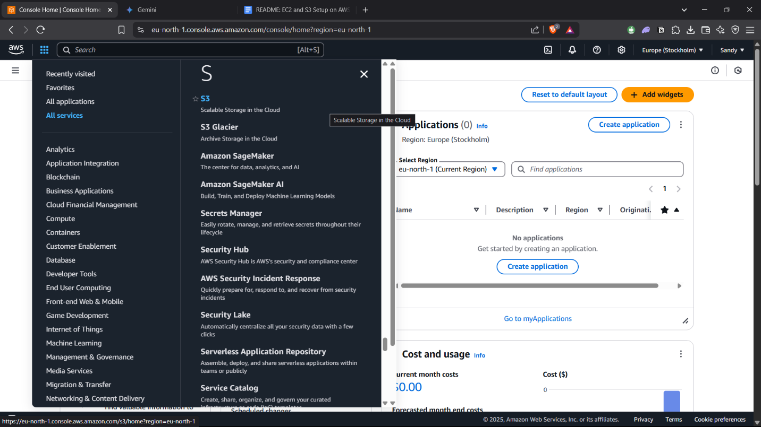  
  
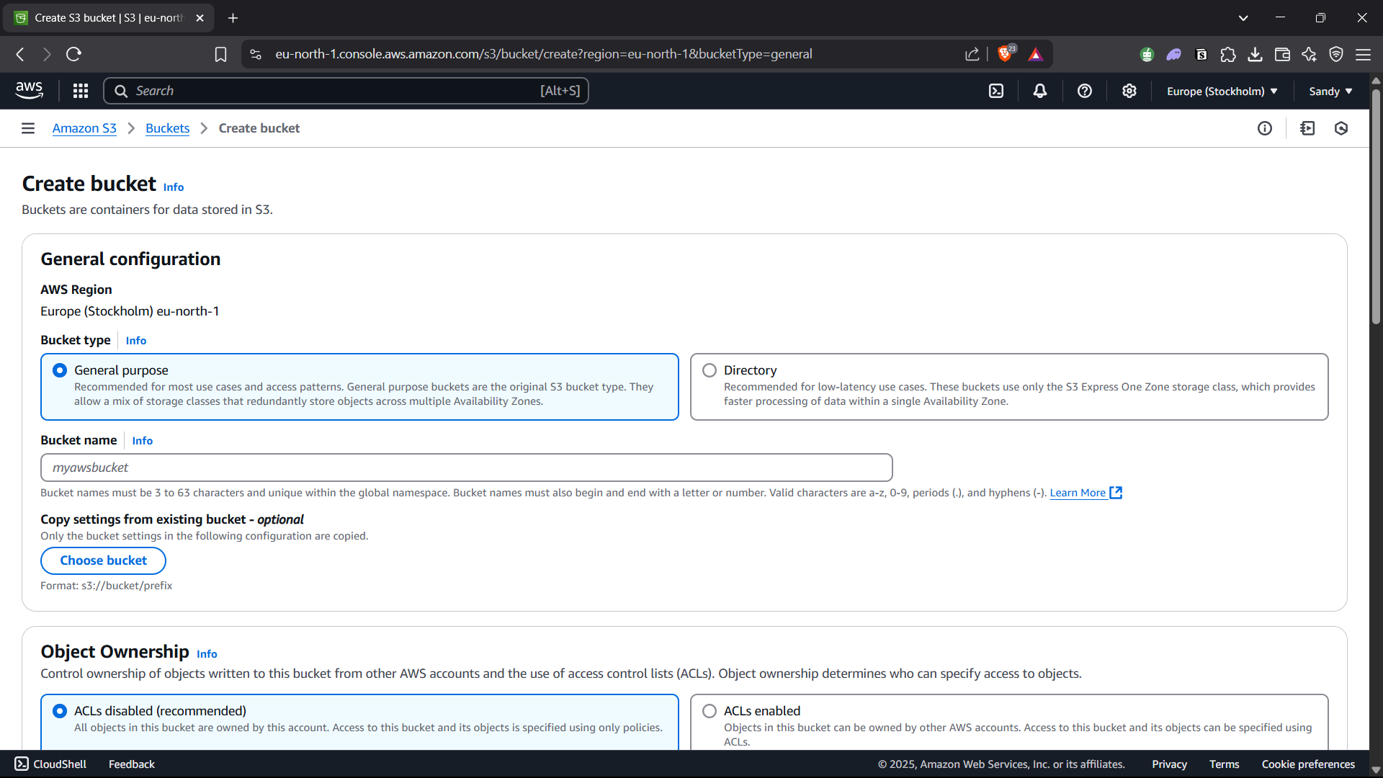  
  
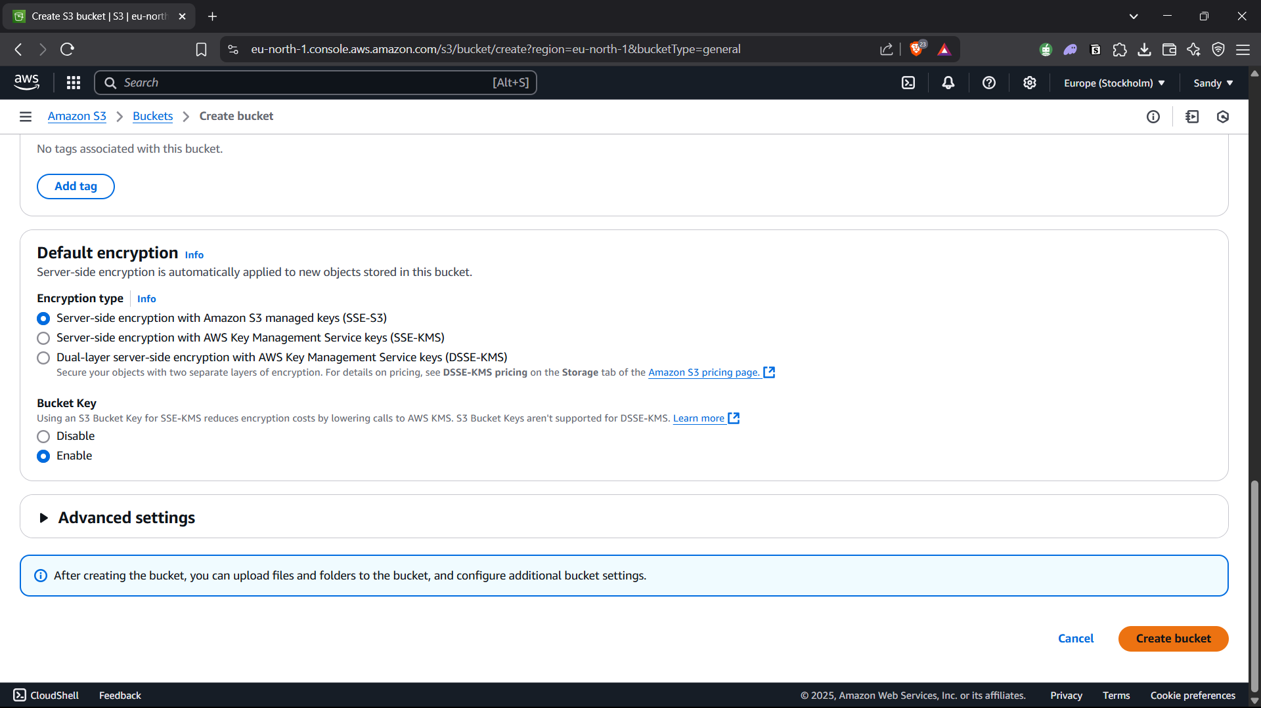

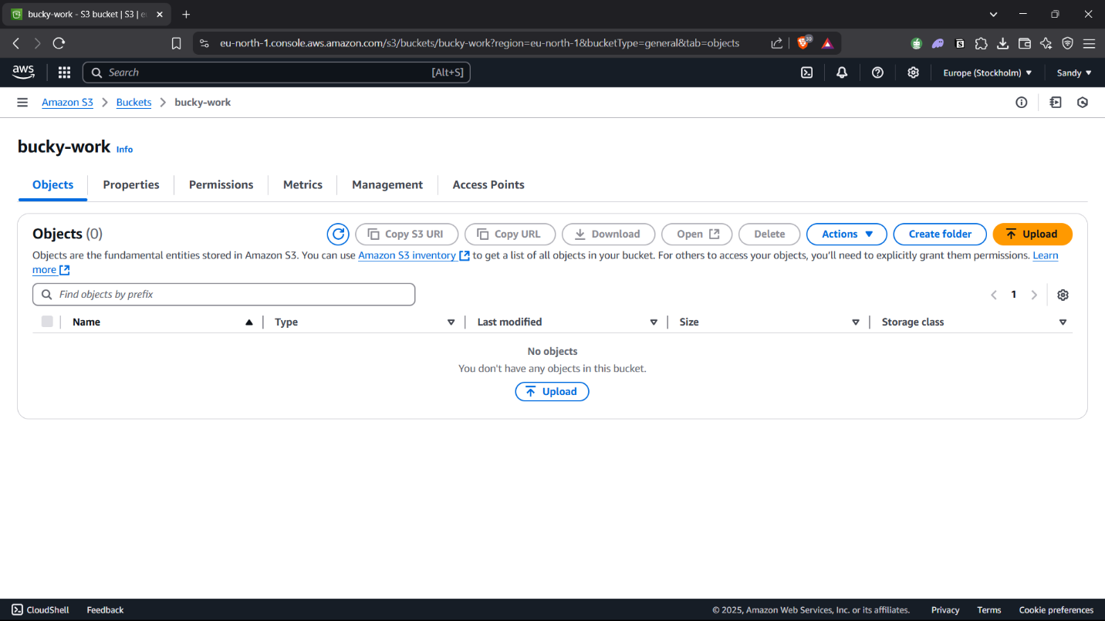  
  
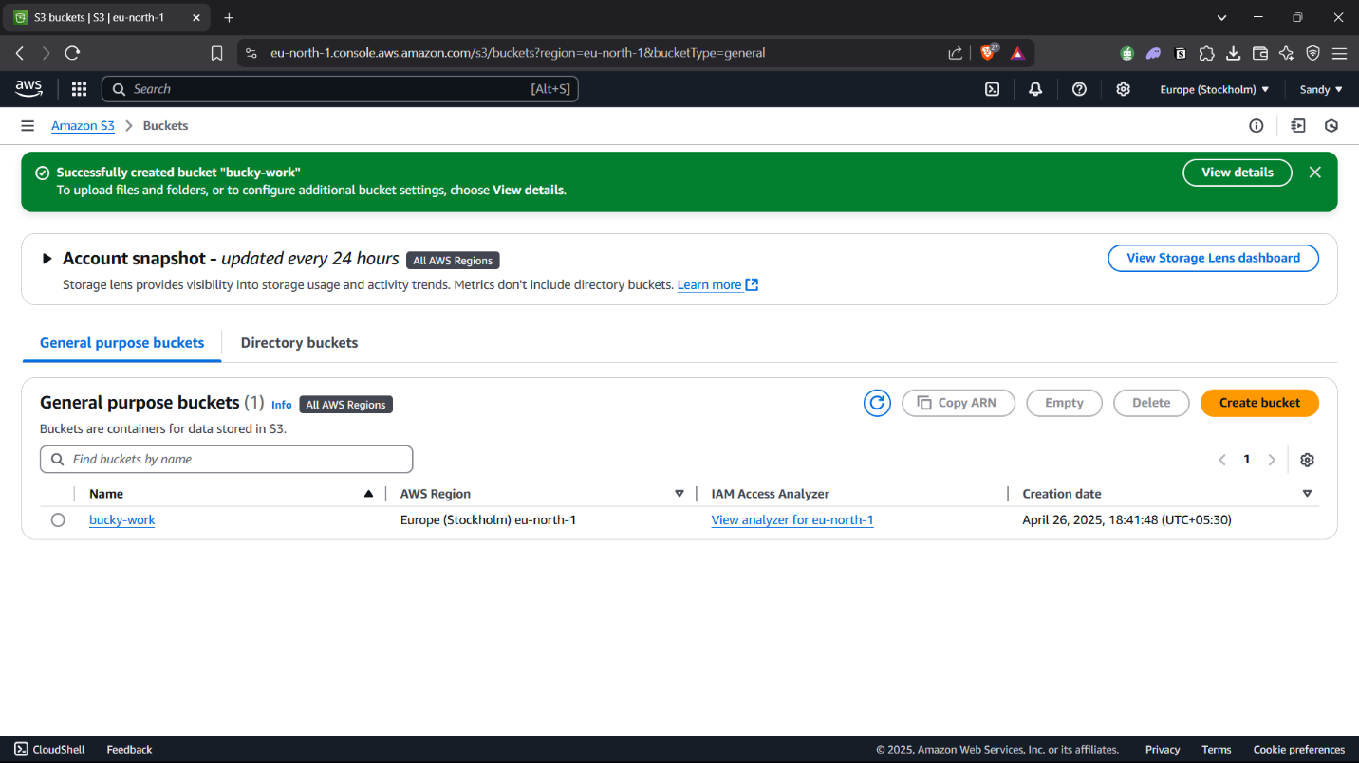

* An S3 bucket has been created in your AWS account.

**Result:**

An EC2 instance and an S3 bucket were created in the AWS platform.